**NAME: KAVYA GUNDALA**

**DATE: 07-12-2023**

* **JOINS- INNER JOIN,LEFT JOIN, RIGHT JOIN, FULL JOIN**

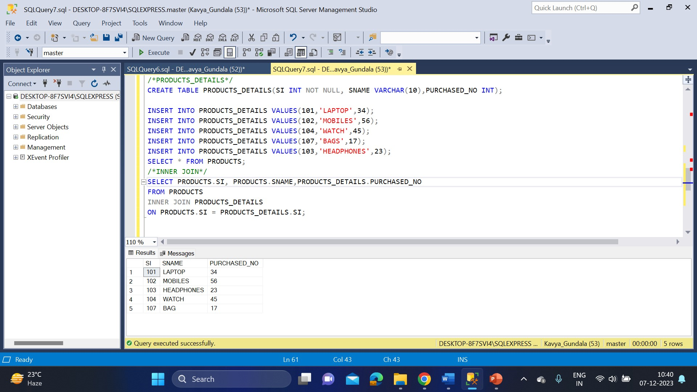

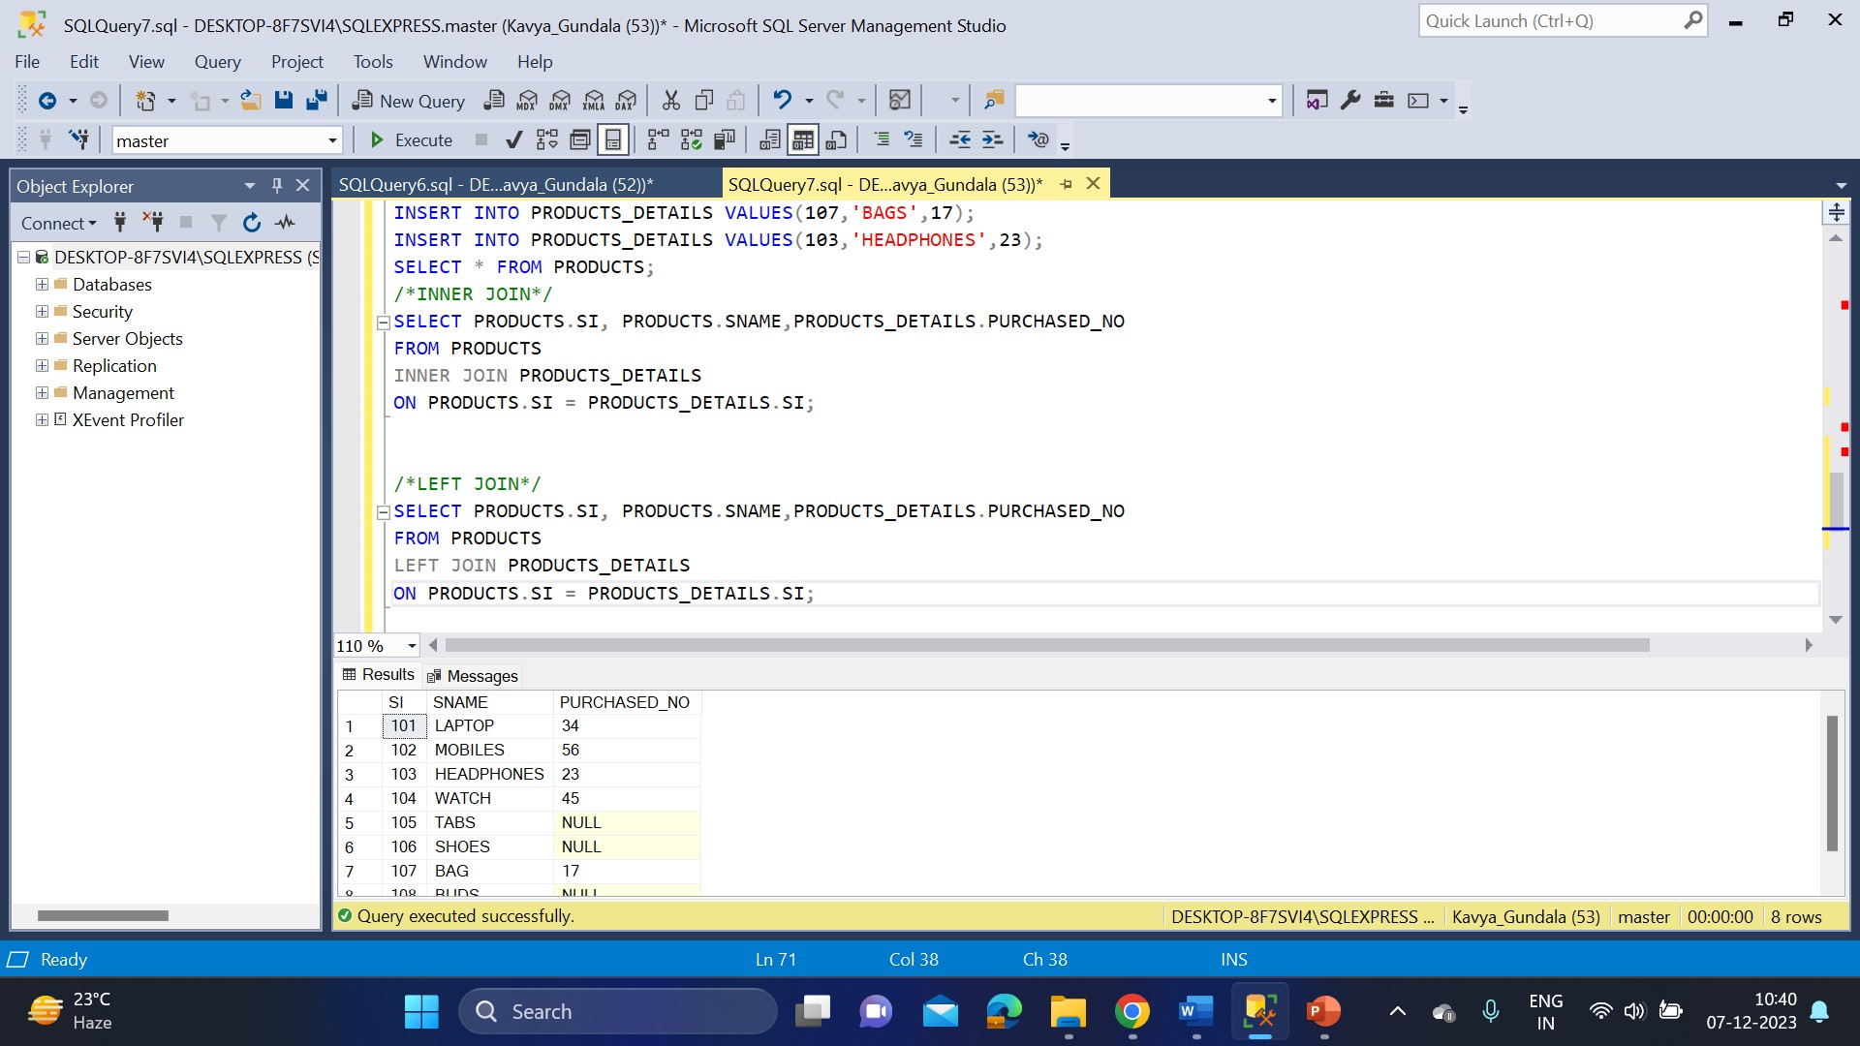

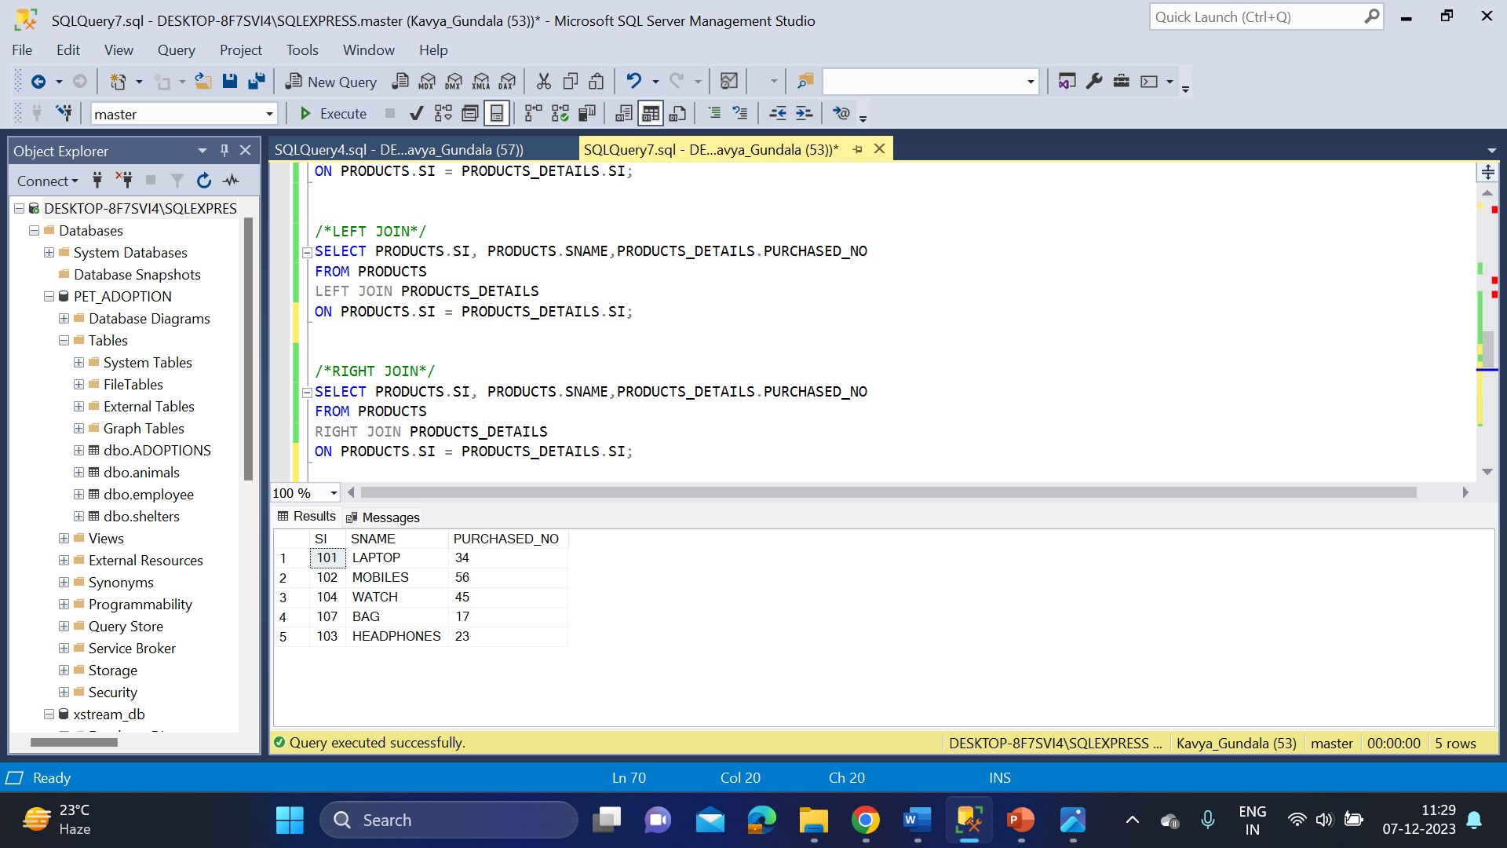

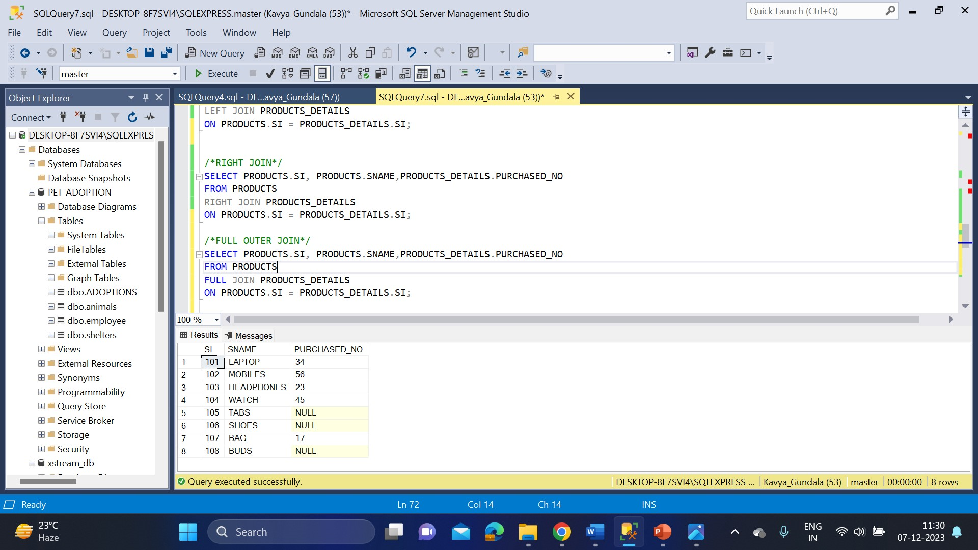

* **ADDITION AND SUBTRACTION OPERATIONS**

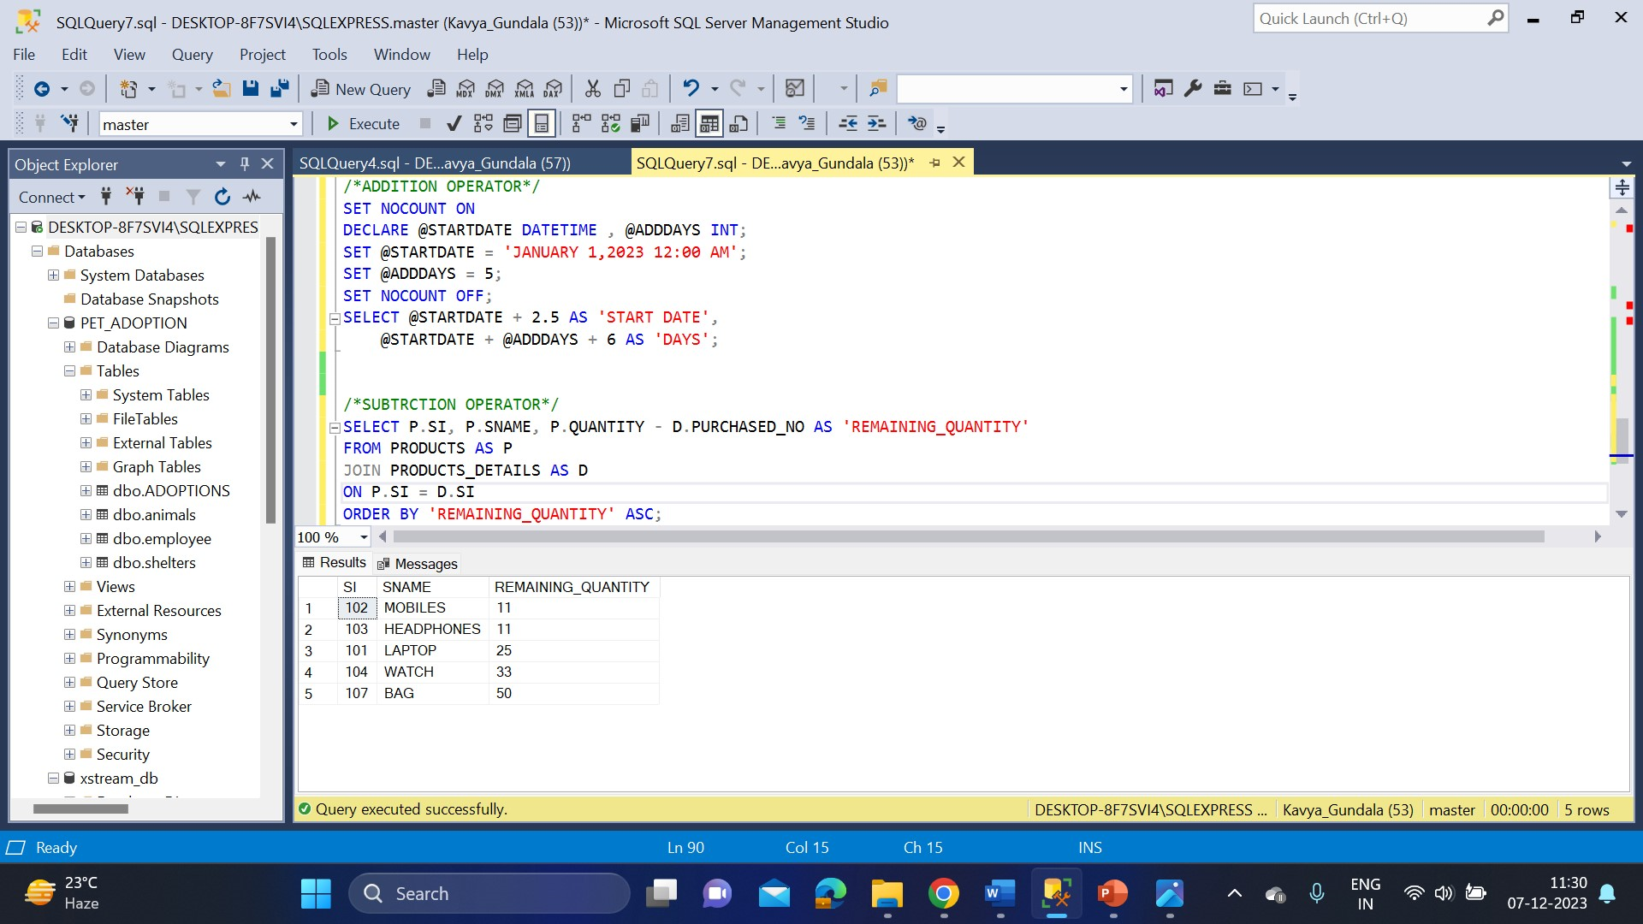

* **STRING FUNCTIONS**

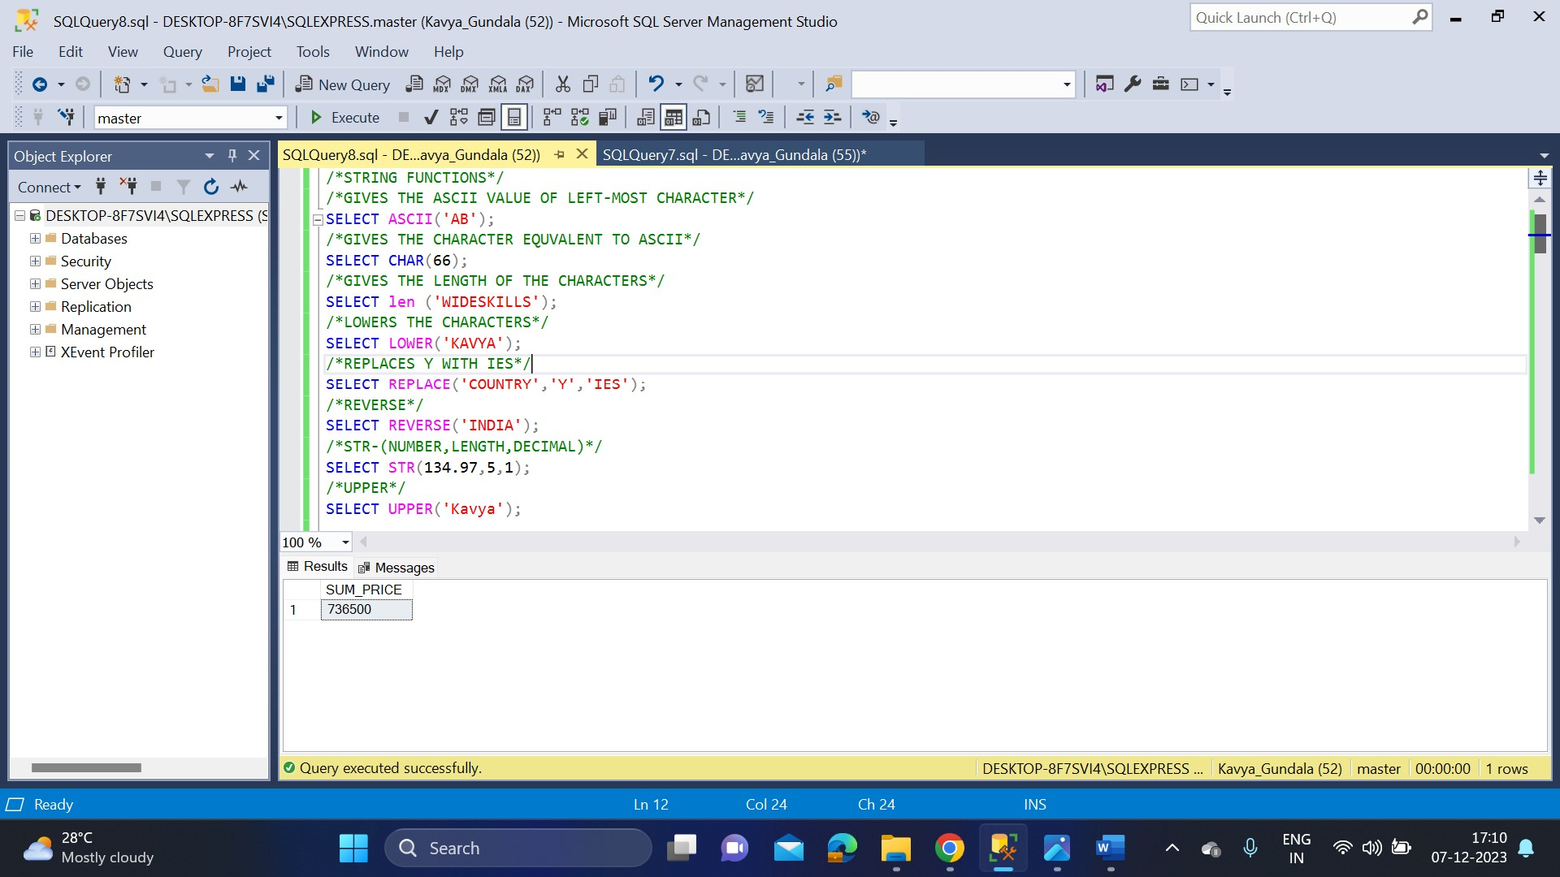

* **DATE FUNCTIONS**

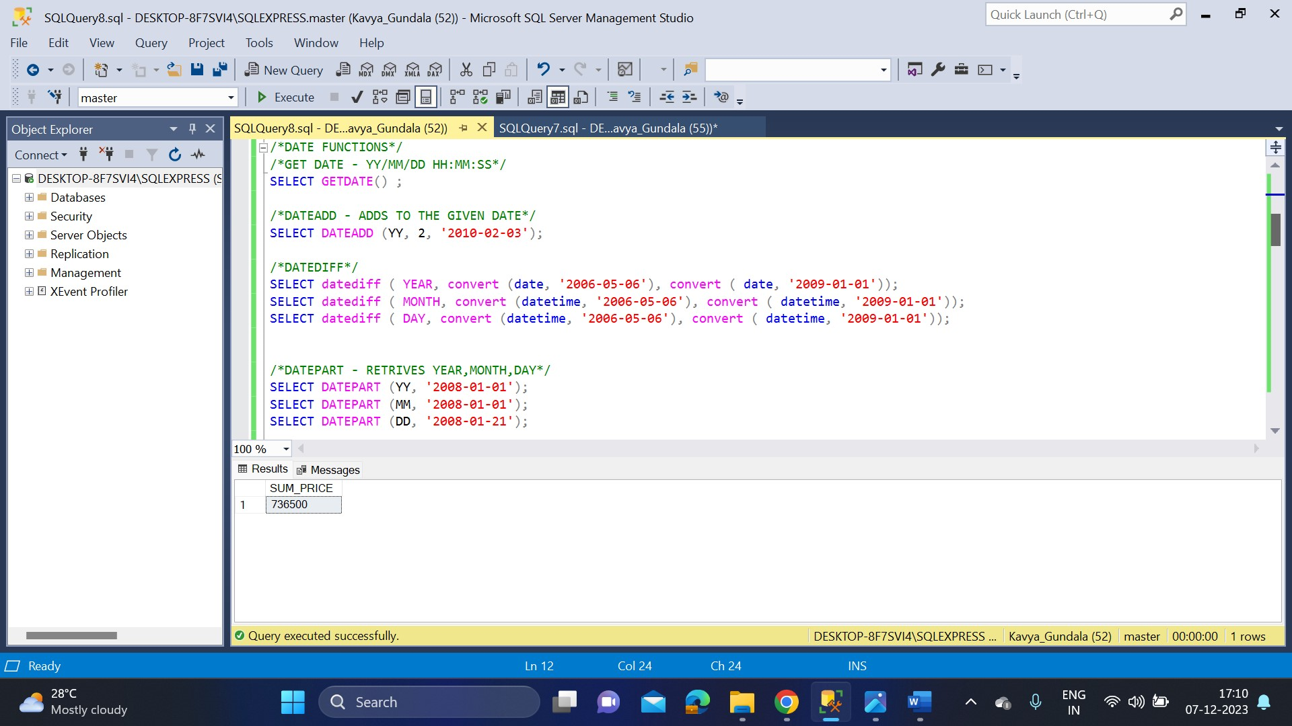

* **MATHMATICAL FUNCTIONS**

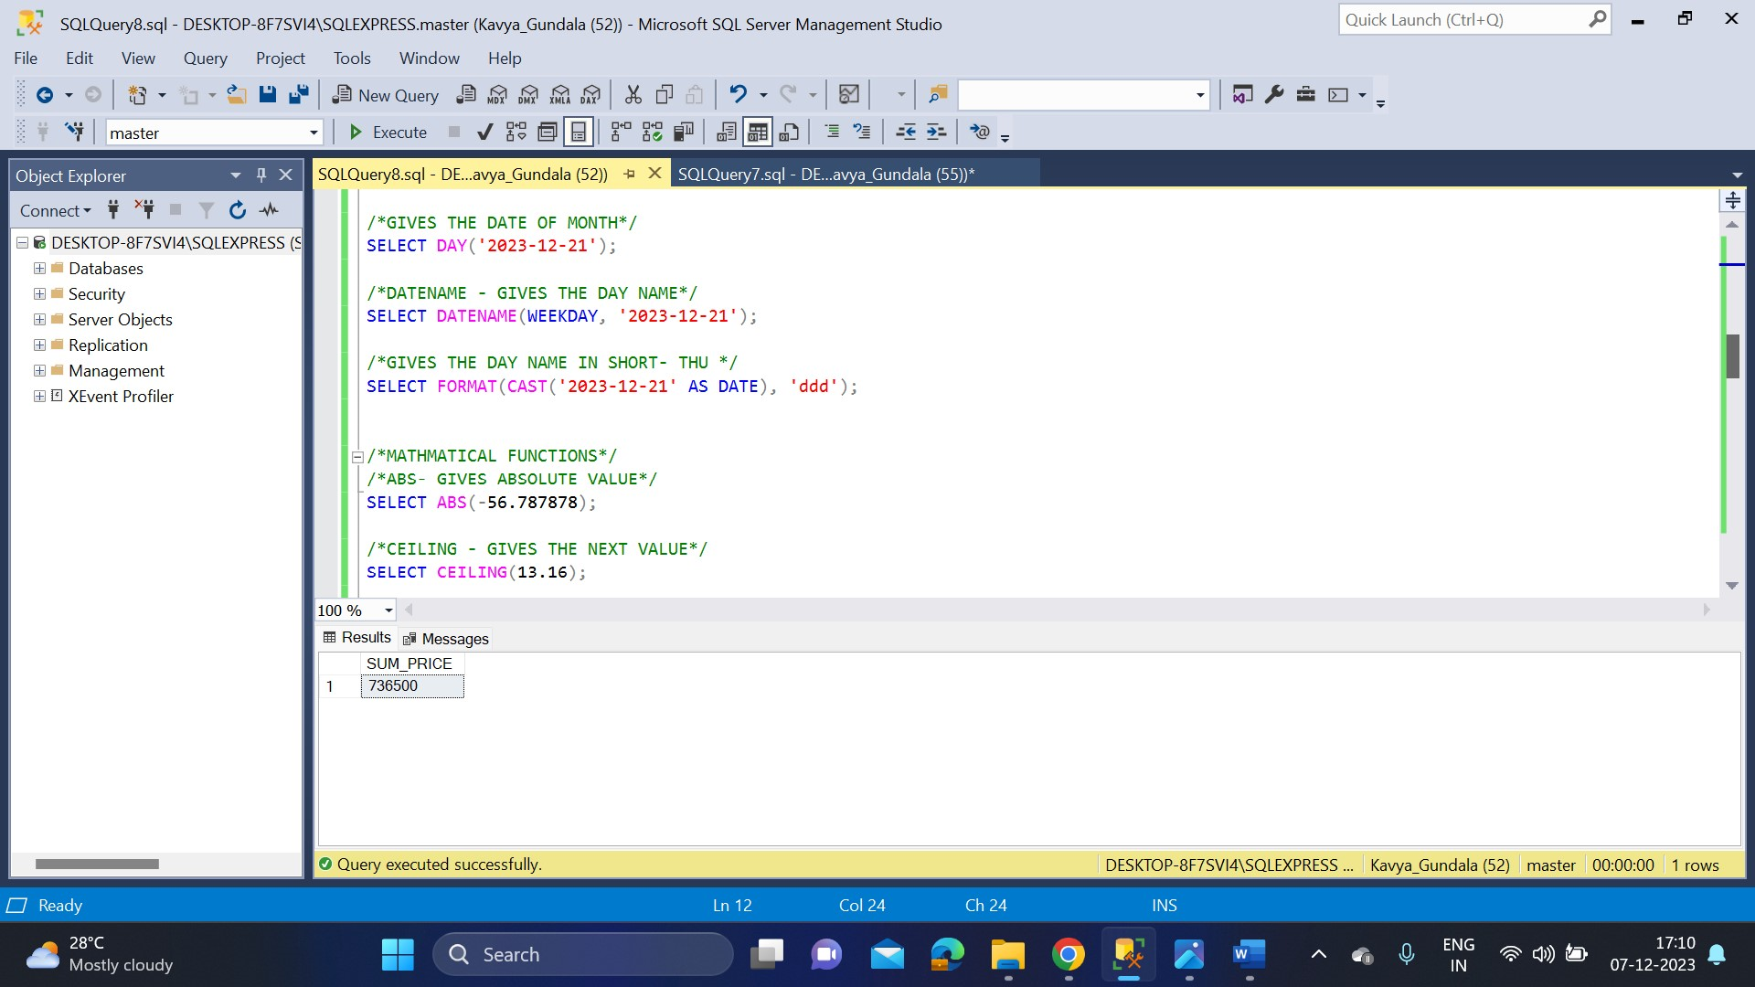

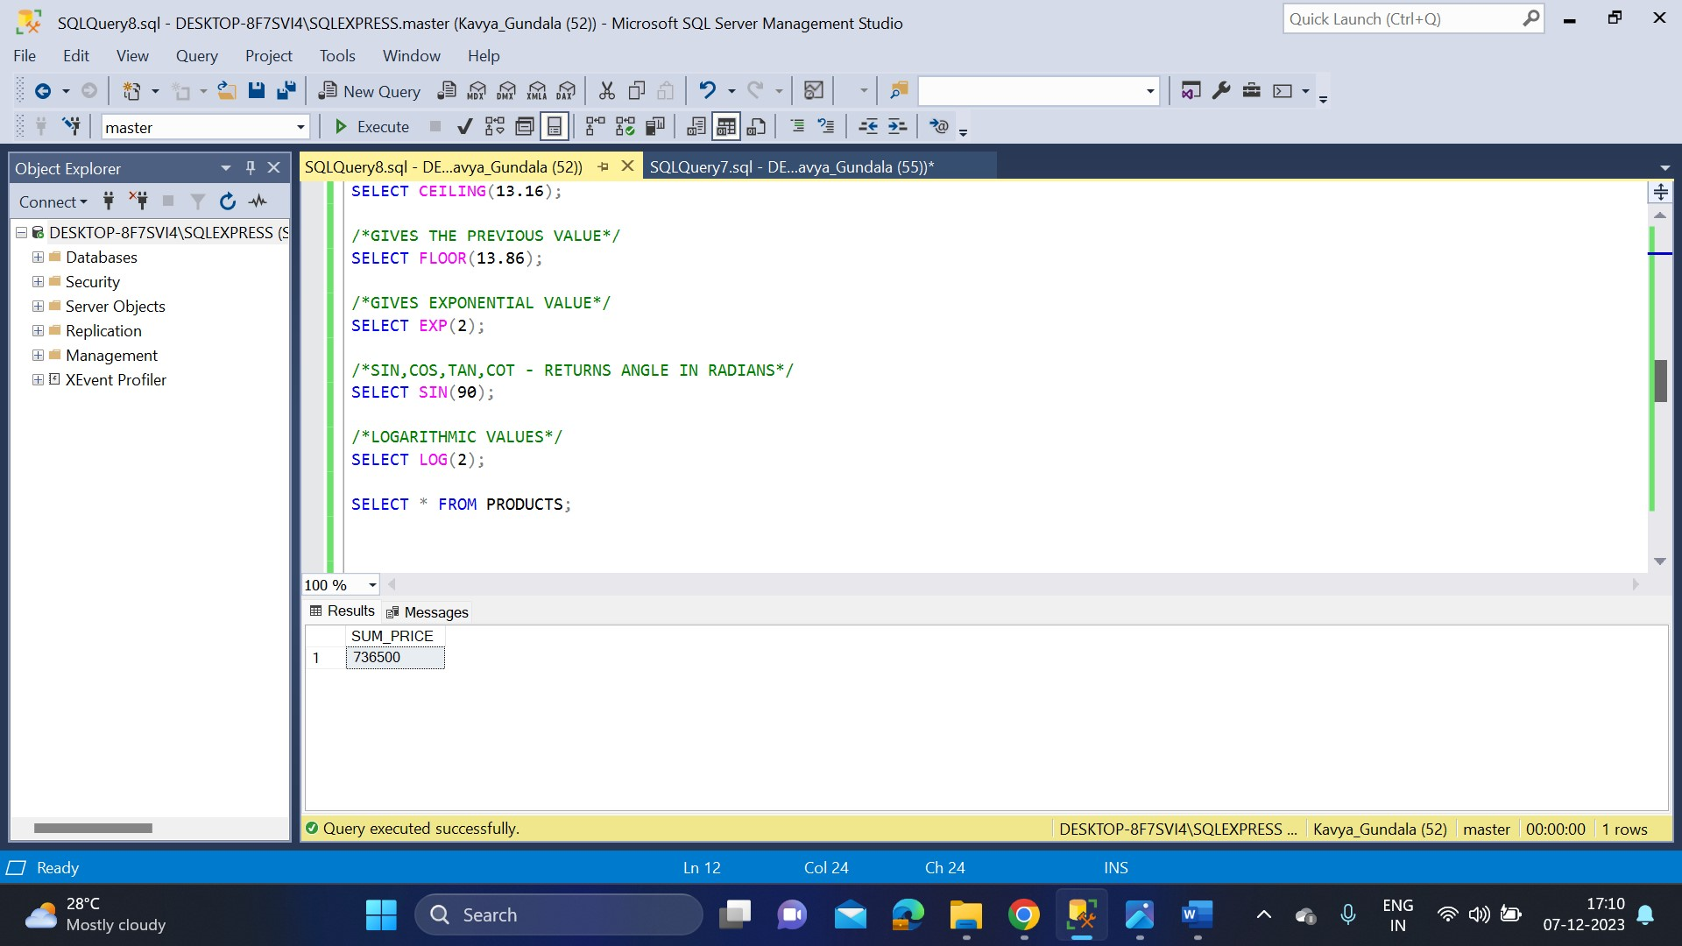

* **RANK FUNCTIONS**

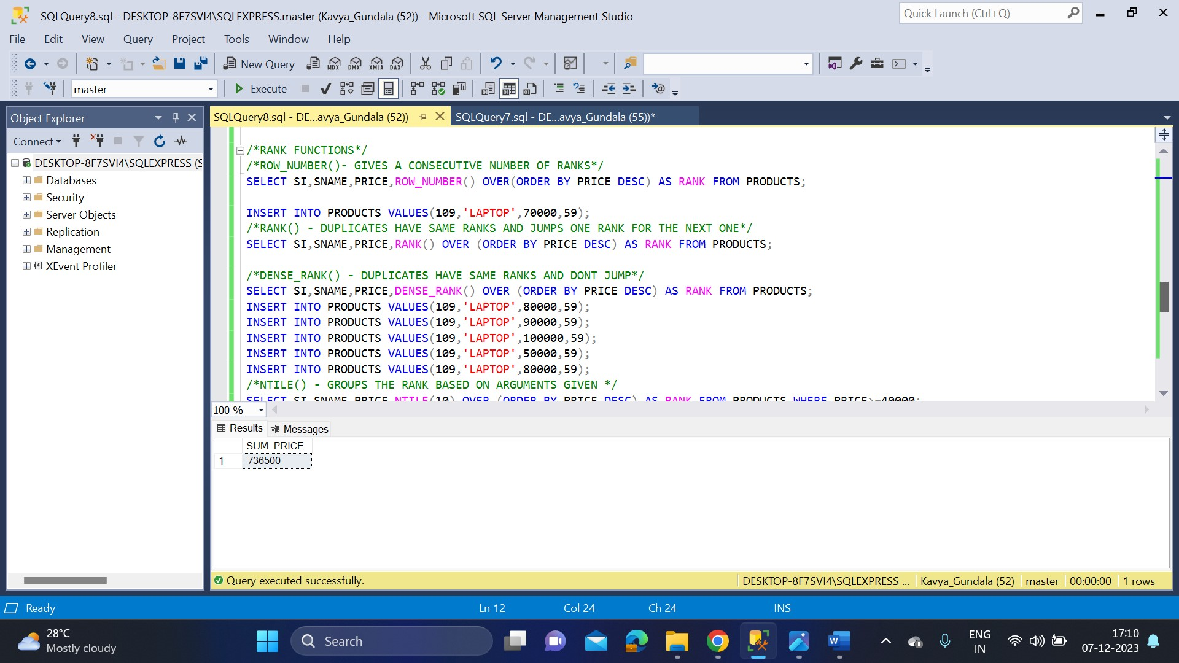

* **SYSTEM FUNCTIONS**

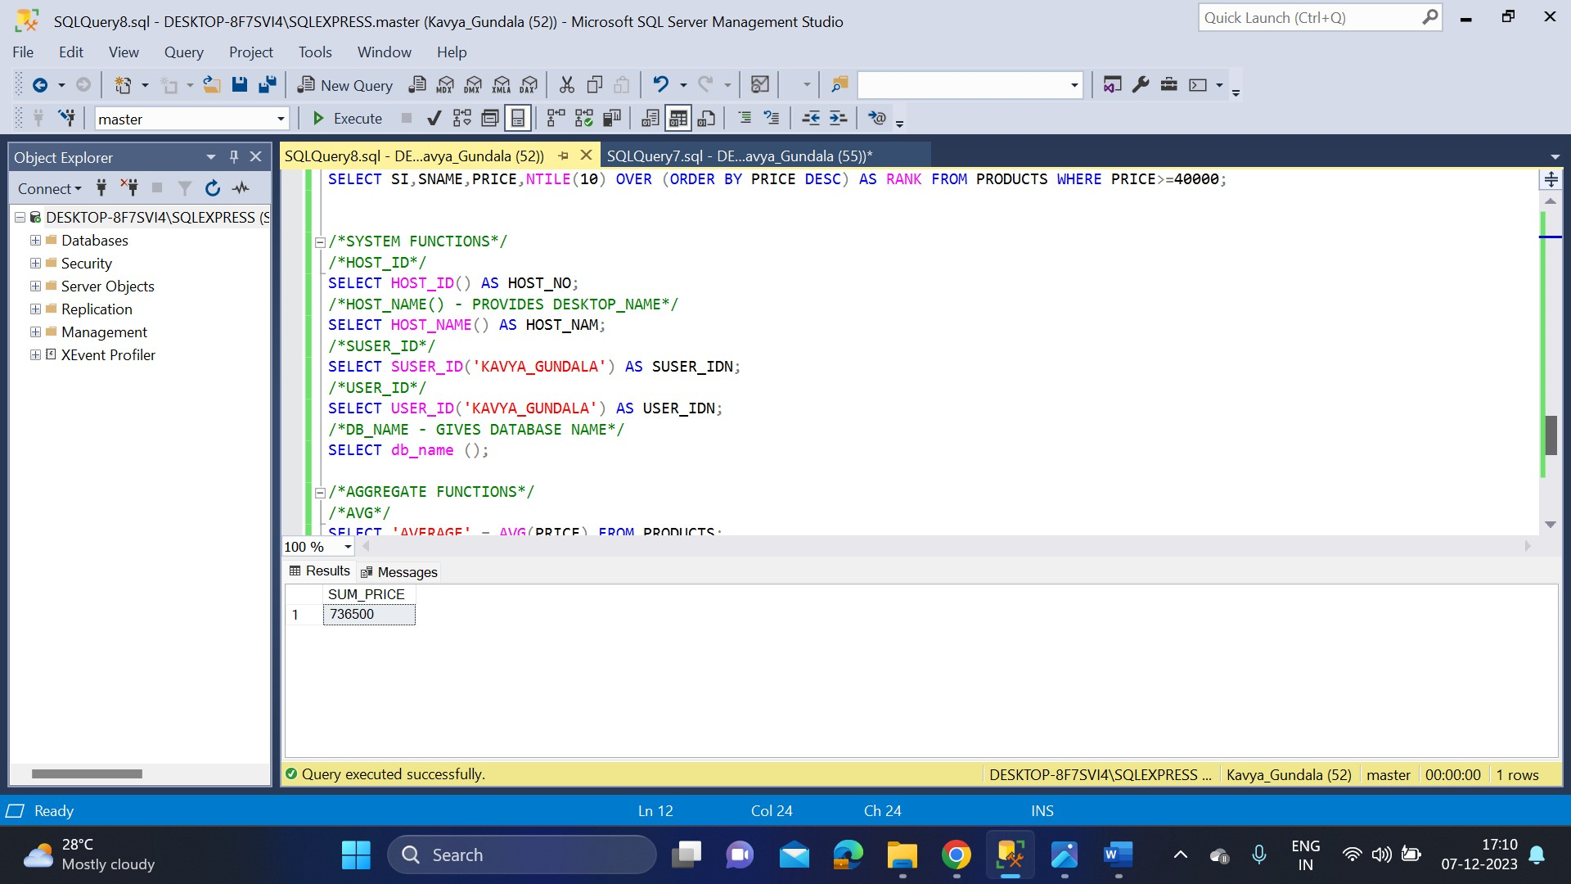

* **AGGREGATE FUMCTIONS**

